**Final Project Report- MWSC.**

1. **Introduction**

A company called The Maracay Metropolitan Water & Sanitation Company (MWSC) needed to implement a customer relations & billing management system to help them administer their customers which is a database that store all the information they want and help in the management of the company. This document is MWSC database project report.

1. **Entity & Query Identification**
   1. **Identified Entities**
      1. **Customer** – This table is for clients of MWSC (**Customer** own **Premise**)

* customer_id
* customer_name
* telephone_number
  + 1. **Premise** – This table is for premises owned by clients of MWSC (**Premise** located in **Zones, Bill Premise, Zone Premise**)
* premise_id
* meter_number
* status
  + 1. **Tariff** – This table is for tariff structure of how they charge (**Charge structure** has **Tariff**)
* tariff_id
* tarrif_name
  + 1. **Zone** – This table contains all the zones of MWSC(**Zone** have **Sector**)
* zone_id
* zone_name
* MonthlySupply
* MonthlyConsumption
* No_Routes
* No_Billers
  + 1. **Bill** – This table contains bills of clients (**Bill** are paid **Payment, Bill** assigned **Premises**)
* bill_id
* No_Zones
  + 1. **Payment** – This table contains payments made by clients
* bill_id
* transaction_id
* amount_paid
* Remaining
  + 1. **Sector** – This table contains all the sectors of MWSC(**Sector** have **Staff**)
* serctor_id
* sector_name
* office_physical_address
* No_Zones
* No_plants
  + 1. **Route** – This table contains all the routes owned by MWSC(**Plant** have **Route, Route** supply **Zone**)
* route_id
* route_name
* Status
  + 1. **Plant** – This table contains all the plants owned by MWSC
* plant_id
* plant_name
* plant_size
  + 1. **Staff** – This table has all MWSC staff(**Staff** make **Bill**)
* staff_id
* staff_name
* No_Clients
  1. **Identified Questions**

|  |  |  |
| --- | --- | --- |
| **#** | **Question** | **SQL Query** |
| 1 | MWSC would like to know how many customers are in each zone | “SELECT zone_id, COUNT(1) FROM table GROUP BY zone_id |
| 2 | MWSC would like to know which premises are active. | SELECT premisesid, FROM premises WHERE status = “active” |
| 3 | MWSC would like to know which premises have been suspended. | SELECT premisesid, FROM premises WHERE status = “suspended” |
| 4 | MWSC would like to know how many zones are In each sector | SELECT COUNT (zoneId) FROM sector |
| 5 | MWSC would like to know how many plants are in each Route | SELECT COUNT (plantId) FROM Route |
| 6 | MWSC should know the tariff that each customer should pay. | SELECT tariff_type FROM Tarriff |

1. **ERDs**
   1. **Entity Relationship Diagram showing the relations between the different entities**

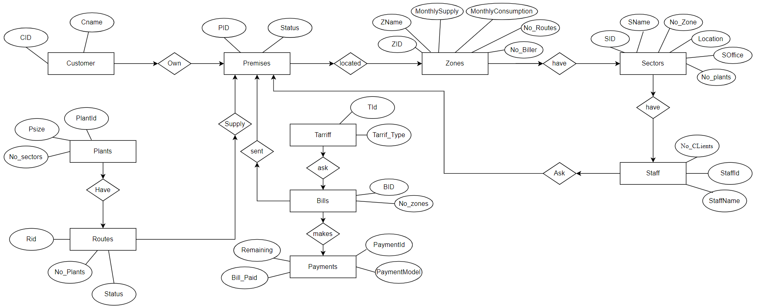

* 1. **Final ERD**

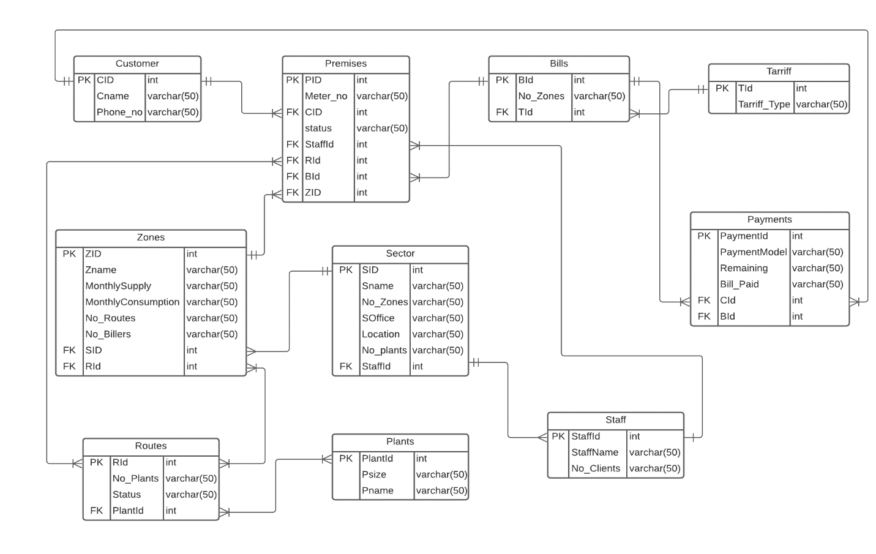

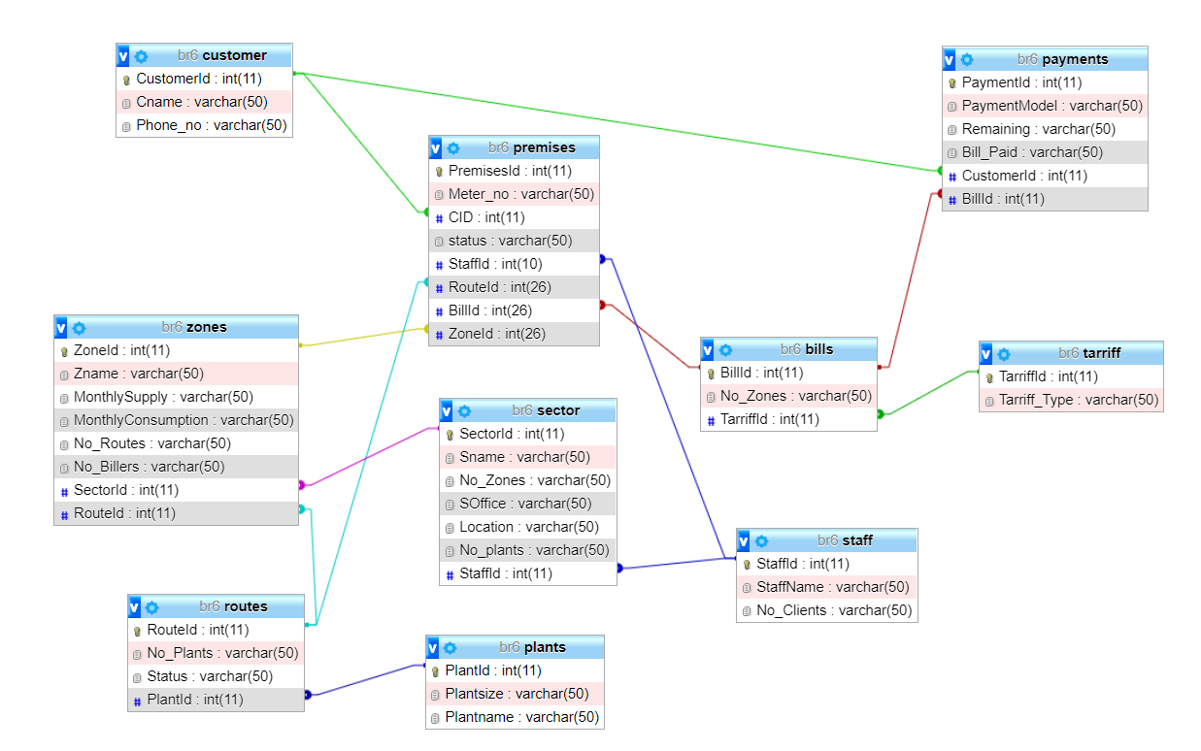

1. **Project Artifacts**

A link to your Database SQL File:

* <https://github.com/IkireziPacifique/BR6/blob/master/MWSCdatabase.sql>

A link to an SQL file containing all your queries:

* <https://github.com/IkireziPacifique/BR6/blob/master/SQL%20Queries.rtf>

1. **Project Learnings –** At least 5 things you learnt from the entire process of developing this project.

* Structured Query Language (SQL): Managing and organizing data in a database
* Relational Algebra: Writing queries to create relations and manage data in the relations
* Entity Relationship Model: Drawing illustrations from a given problem
* Entity Relationship Design: Drawing Entities to make data be ready to be put in a database
* Database: Creating and Managing a database.